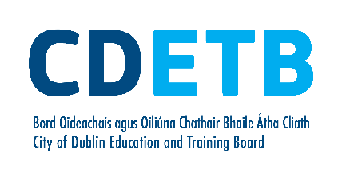 | Vetting Invitation Form (NVB1 – V2)  Guidelines for completion
Please read the following guidelines before completing this form:
Miscellaneous:
- The Form must be completed in full using BLOCK CAPITALS and writing must be clear and legible.
- The Form should be completed in ball point pen.
- Photocopies will not be accepted.
- All applicants will be required to provide documents to validate their identity.
- If the applicant is under 18 years of age, a completed NVB3 – Parent/Guardian Consent form will be required. Please note that where the applicant is under 18 years of age the electronic correspondence will issue to the Parent/Guardian. This being the case, the applicant must provide their Parent/Guardian email address on the NVB1 form.

Personal Details:
- Insert details for each field, allowing one block letter per box.
- For Date of Birth field, allow one digit per box
- Please fill in your Email Address (or that of your Parent/Guardian if you are under 18 years of age), allowing one character/symbol per box. This is required as the invitation to e-vetting will be sent to this address. Please ensure that if there are numbers in your email address, it is clear that they are numbers rather than letters. For example, the number zero (0) can often be mistaken for the letter “O”, number one (1) for the letter “I” etc.
- Please allow one digit per box for your contact number.
- The Current Address means the address you are now living at.
- The address fields should be completed in full, including Eircode/Postcode. No abbreviations.

Role Being Vetted For:
- The role being applied for must be clearly stated. Generic terms such as “Volunteer” will not suffice.

Declaration of Application:
- The applicant must confirm their understanding and acceptance of the two statements by signing the application form at Section 2 and ticking the box provided.

City of Dublin Education and  Training Board  Administrative Offices  Town Hall  Ballsbridge  Dublin 4 | 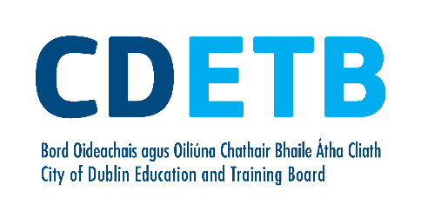 | Your Ref:
Form NVB 1 (V2)

Vetting Invitation

Section 1 – Personal Information
Under Sec 26(b) of the National Vetting Bureau (Children and Vulnerable Persons) Acts 2012 to 2016, it is an offence to make a false statement for the purpose of obtaining a vetting disclosure.
Forename:
Middle Name:
Surname:
Date of birth: |  |  | / |  |  | /
 | d | d |  | m | m |  | y | y | y | y
*Email Address:
 | * Where an applicant for vetting is under 18 years of age, the email required is that of the Parent/Guardian
Contact Number:
Role Being
Vetted For:
Current Address:
Line 1:
Line 2:
Line 3:
Line 4:
Line 5:
Eircode/Postcode:

Section 2 – Additional Information

Name of Organisation:
I have provided documentation to validate my identity as required and
I consent to the making of this application and to the disclosure of information by the National Vetting Bureau to the Liaison Person pursuant to Section 13(4)(e) National Vetting Bureau (Children and Vulnerable Persons) Acts 2012 to 2016.
Please tick box r

Applicant’s Signature: |  | Date: |  |  | / |  |  | /
 |  |  | d | d |  | m | m |  | y | y | y | y

Note: Please return this form to the Principal/Head of Centre/HR Department as appropriate.
An invitation to the e-vetting website will then be sent to your email address.

